Digital Image Processing
Laboratory Record — Image & Video Handling using Python (OpenCV)
Contains: Aim, Algorithm, Program Code, and Output for 40 experiments

Experiment 1: Convert an Image to Grayscale
Aim:
To read a color image using Python (OpenCV) and convert it into a grayscale image.
Algorithm:
1. Import the OpenCV library (cv2).
2. Read the input color image using cv2.imread().
3. Convert the BGR color image to grayscale using cv2.cvtColor() with the flag COLOR_BGR2GRAY.
4. Display / save the original and grayscale images.
5. Wait for a key press and close all windows.
Program (Python):
import cv2

# Read the image
img = cv2.imread("image.jpg")

# Convert to Grayscale
gray_img = cv2.cvtColor(img, cv2.COLOR_BGR2GRAY)

# Save and display
cv2.imwrite("gray_output.jpg", gray_img)
cv2.imshow("Grayscale Image", gray_img)
cv2.waitKey(0)
cv2.destroyAllWindows()
Output:
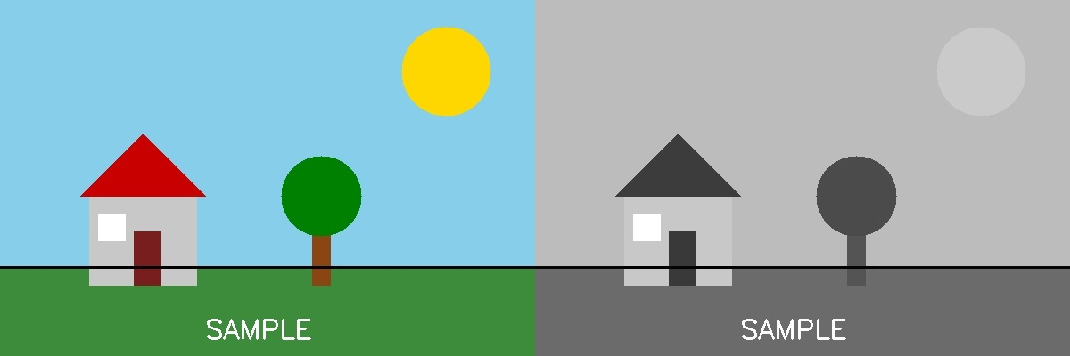

Experiment 2: Convert an Image to Blur using GaussianBlur
Aim:
To read an image and apply Gaussian Blur to smoothen/blur it using OpenCV.
Algorithm:
1. Import the OpenCV library.
2. Read the input image using cv2.imread().
3. Apply cv2.GaussianBlur() with a chosen odd-sized kernel (e.g. 15x15) and sigmaX = 0.
4. Save and display the original and blurred images.
5. Wait for a key press and close all windows.
Program (Python):
import cv2

img = cv2.imread("image.jpg")

# Apply Gaussian Blur
blurred_img = cv2.GaussianBlur(img, (15, 15), 0)

cv2.imwrite("blurred_output.jpg", blurred_img)
cv2.imshow("Blurred Image", blurred_img)
cv2.waitKey(0)
cv2.destroyAllWindows()
Output:
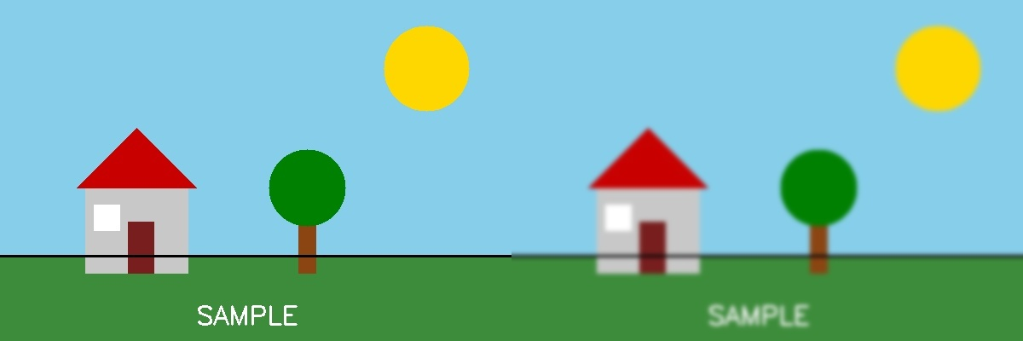

Experiment 3: Show Outline of an Image using Canny Function
Aim:
To detect and display the edges/outline of an image using the Canny edge detection algorithm.
Algorithm:
1. Import OpenCV.
2. Read the input image.
3. Convert the image to grayscale (Canny works on single-channel images).
4. Apply cv2.Canny() with lower and upper threshold values (e.g. 100, 200).
5. Display and save the resulting edge/outline image.
Program (Python):
import cv2

img = cv2.imread("image.jpg")
gray_img = cv2.cvtColor(img, cv2.COLOR_BGR2GRAY)

# Apply Canny Edge Detection
edges = cv2.Canny(gray_img, threshold1=100, threshold2=200)

cv2.imwrite("outline_output.jpg", edges)
cv2.imshow("Outline (Canny Edges)", edges)
cv2.waitKey(0)
cv2.destroyAllWindows()
Output:
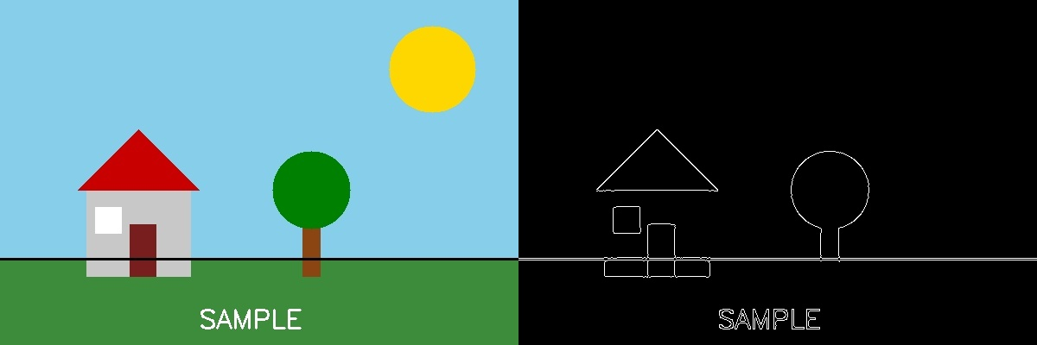

Experiment 4: Dilate an Image using Dilate Function
Aim:
To read an image and apply the morphological Dilation operation to expand bright regions.
Algorithm:
1. Import OpenCV and NumPy.
2. Read the input image.
3. Define a structuring element (kernel), e.g. a 5x5 matrix of ones.
4. Apply cv2.dilate() on the image using the kernel.
5. Display and save the dilated image.
Program (Python):
import cv2
import numpy as np

img = cv2.imread("image.jpg")
kernel = np.ones((5, 5), np.uint8)

# Apply Dilation
dilated_img = cv2.dilate(img, kernel, iterations=1)

cv2.imwrite("dilated_output.jpg", dilated_img)
cv2.imshow("Dilated Image", dilated_img)
cv2.waitKey(0)
cv2.destroyAllWindows()
Output:
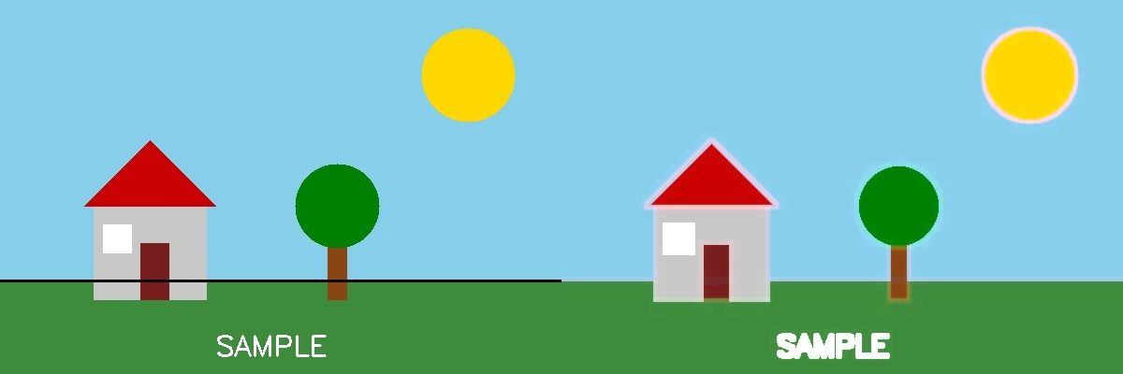

Experiment 5: Erode an Image using Erode Function
Aim:
To read an image and apply the morphological Erosion operation to shrink bright regions.
Algorithm:
1. Import OpenCV and NumPy.
2. Read the input image.
3. Define a structuring element (kernel), e.g. a 5x5 matrix of ones.
4. Apply cv2.erode() on the image using the kernel.
5. Display and save the eroded image.
Program (Python):
import cv2
import numpy as np

img = cv2.imread("image.jpg")
kernel = np.ones((5, 5), np.uint8)

# Apply Erosion
eroded_img = cv2.erode(img, kernel, iterations=1)

cv2.imwrite("eroded_output.jpg", eroded_img)
cv2.imshow("Eroded Image", eroded_img)
cv2.waitKey(0)
cv2.destroyAllWindows()
Output:
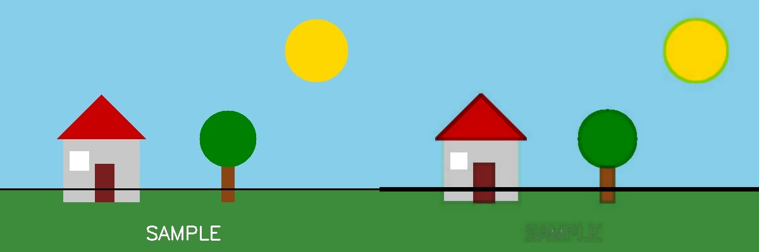

Experiment 6: Read a Captured Video and Display in Slow Motion / Fast Motion
Aim:
To read a previously captured video file using OpenCV and play it back in slow motion and fast motion by controlling the frame delay.
Algorithm:
1. Import OpenCV.
2. Open the video file using cv2.VideoCapture().
3. Read the video's original FPS using cap.get(cv2.CAP_PROP_FPS).
4. Compute the normal per-frame delay = 1000/FPS (ms).
5. For slow motion, multiply the delay (increase wait time between frames).
6. For fast motion, divide the delay (decrease wait time between frames).
7. Loop: read each frame with cap.read(), display it with cv2.imshow(), and use cv2.waitKey(delay).
8. Release the capture and close windows when done or 'q' is pressed.
Program (Python):
import cv2

cap = cv2.VideoCapture("input_video.mp4")
fps = cap.get(cv2.CAP_PROP_FPS)
normal_delay = int(1000 / fps)

slow_delay = normal_delay * 3 # Slow motion
fast_delay = max(1, normal_delay // 3) # Fast motion

mode = "slow" # change to "fast" to test fast motion

while cap.isOpened():
ret, frame = cap.read()
if not ret:
break
cv2.imshow("Video", frame)
delay = slow_delay if mode == "slow" else fast_delay
if cv2.waitKey(delay) & 0xFF == ord('q'):
break

cap.release()
cv2.destroyAllWindows()
Output:
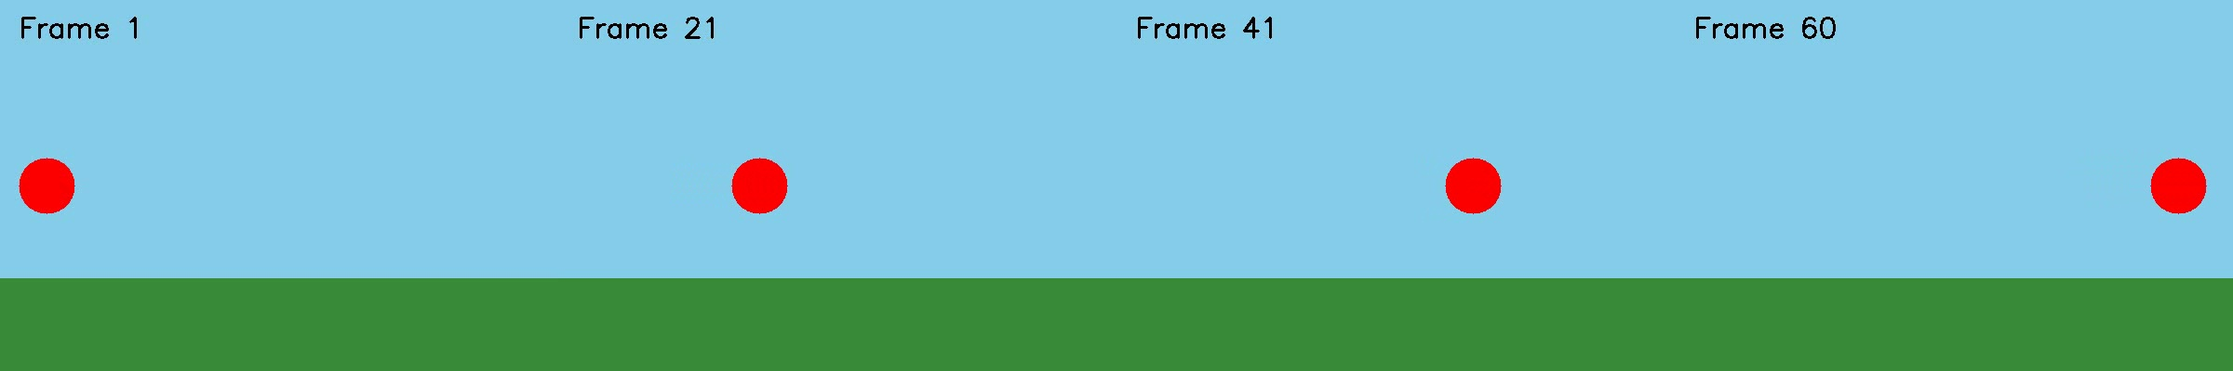
Sample frames extracted from the played-back video (frame progression shown left to right).

Experiment 7: Capture Video from Webcam and Display in Slow Motion / Fast Motion
Aim:
To capture a live video stream from the webcam and display it in slow motion and fast motion.
Algorithm:
1. Import OpenCV.
2. Open the default webcam using cv2.VideoCapture(0).
3. Set delay values for normal, slow, and fast playback modes.
4. Loop: read each frame using cap.read().
5. Display the frame using cv2.imshow() with cv2.waitKey(delay) controlling playback speed.
6. Break the loop when 'q' is pressed.
7. Release the camera and destroy all windows.
Program (Python):
import cv2

cap = cv2.VideoCapture(0) # 0 = default webcam

mode = "fast" # change to "slow" to test slow motion
normal_delay = 30
slow_delay = 90
fast_delay = 10

while True:
ret, frame = cap.read()
if not ret:
break
cv2.imshow("Webcam Video", frame)
delay = slow_delay if mode == "slow" else fast_delay
if cv2.waitKey(delay) & 0xFF == ord('q'):
break

cap.release()
cv2.destroyAllWindows()
Output:

Sample webcam frames shown at different playback speeds (illustrative — captured from a live camera feed).

Experiment 8: Scaling an Image to Bigger and Smaller Sizes
Aim:
To resize (scale) an image to a larger size and a smaller size using OpenCV.
Algorithm:
1. Import OpenCV.
2. Read the input image.
3. Use cv2.resize() with fx, fy > 1 (e.g. 1.6) and INTER_LINEAR interpolation to enlarge.
4. Use cv2.resize() with fx, fy < 1 (e.g. 0.5) and INTER_AREA interpolation to shrink.
5. Display and save both resized images alongside the original.
Program (Python):
import cv2

img = cv2.imread("image.jpg")

# Bigger (1.6x)
bigger = cv2.resize(img, None, fx=1.6, fy=1.6, interpolation=cv2.INTER_LINEAR)

# Smaller (0.5x)
smaller = cv2.resize(img, None, fx=0.5, fy=0.5, interpolation=cv2.INTER_AREA)

cv2.imshow("Original", img)
cv2.imshow("Bigger", bigger)
cv2.imshow("Smaller", smaller)
cv2.waitKey(0)
cv2.destroyAllWindows()
Output:
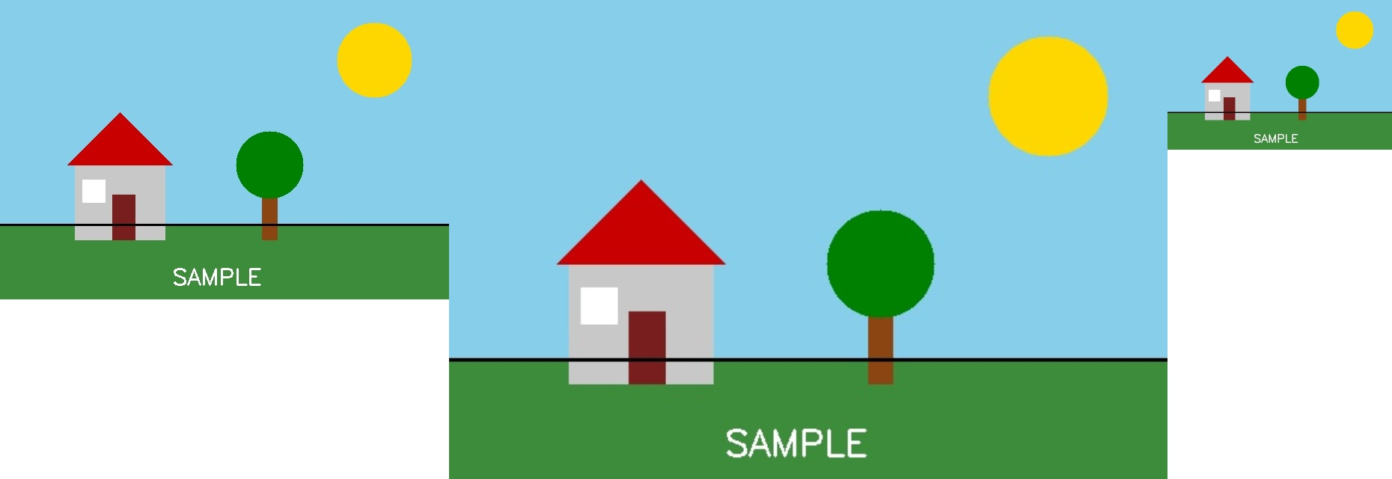
Left to right: Original, Bigger (1.6x), Smaller (0.5x).

Experiment 9: Rotation of an Image Clockwise and Counter-Clockwise
Aim:
To rotate an image in the clockwise and counter-clockwise directions using OpenCV's rotation matrix.
Algorithm:
1. Import OpenCV.
2. Read the input image and find its center point.
3. Compute a rotation matrix using cv2.getRotationMatrix2D(center, angle, scale) — a negative angle rotates clockwise, positive rotates counter-clockwise.
4. Apply the rotation matrix using cv2.warpAffine().
5. Display and save both rotated images.
Program (Python):
import cv2

img = cv2.imread("image.jpg")
(h, w) = img.shape[:2]
center = (w // 2, h // 2)

# Clockwise rotation (negative angle)
M_clockwise = cv2.getRotationMatrix2D(center, -45, 1.0)
rotated_clockwise = cv2.warpAffine(img, M_clockwise, (w, h))

# Counter-clockwise rotation (positive angle)
M_counter = cv2.getRotationMatrix2D(center, 45, 1.0)
rotated_counter = cv2.warpAffine(img, M_counter, (w, h))

cv2.imshow("Clockwise", rotated_clockwise)
cv2.imshow("Counter-Clockwise", rotated_counter)
cv2.waitKey(0)
cv2.destroyAllWindows()
Output:
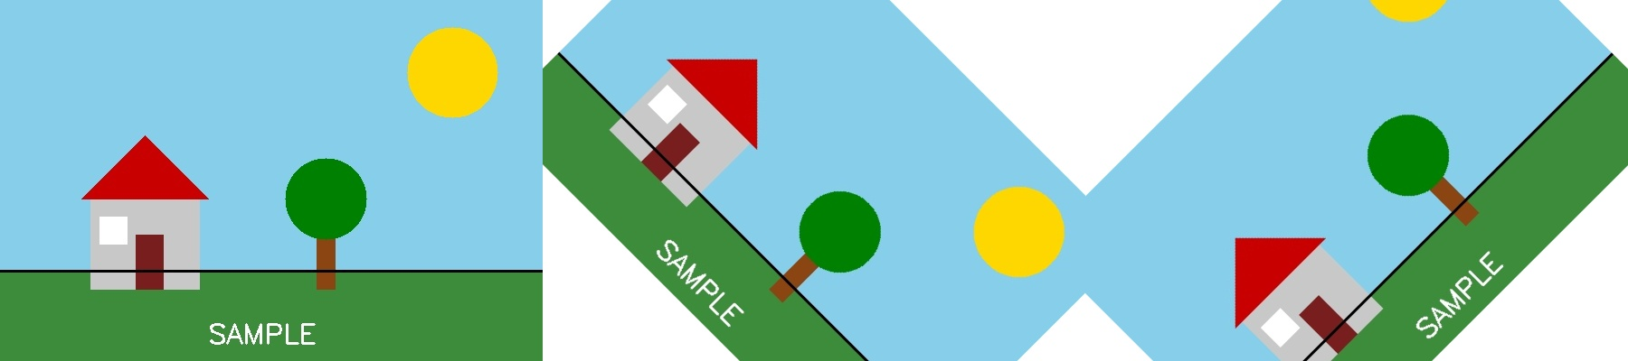
Left to right: Original, Clockwise (-45°), Counter-Clockwise (+45°).

Experiment 10: Moving (Translating) an Image from One Place to Another
Aim:
To shift/translate an image from one position to another using an affine translation matrix.
Algorithm:
1. Import OpenCV and NumPy.
2. Read the input image and note its dimensions.
3. Define horizontal shift (tx) and vertical shift (ty) values.
4. Build a 2x3 translation matrix: [[1,0,tx],[0,1,ty]].
5. Apply cv2.warpAffine() with this matrix to translate the image.
6. Display and save the translated image.
Program (Python):
import cv2
import numpy as np

img = cv2.imread("image.jpg")
(h, w) = img.shape[:2]

tx, ty = 100, 50 # shift right by 100 px, down by 50 px
M = np.float32([[1, 0, tx], [0, 1, ty]])

translated = cv2.warpAffine(img, M, (w, h))

cv2.imshow("Original", img)
cv2.imshow("Translated", translated)
cv2.waitKey(0)
cv2.destroyAllWindows()
Output:
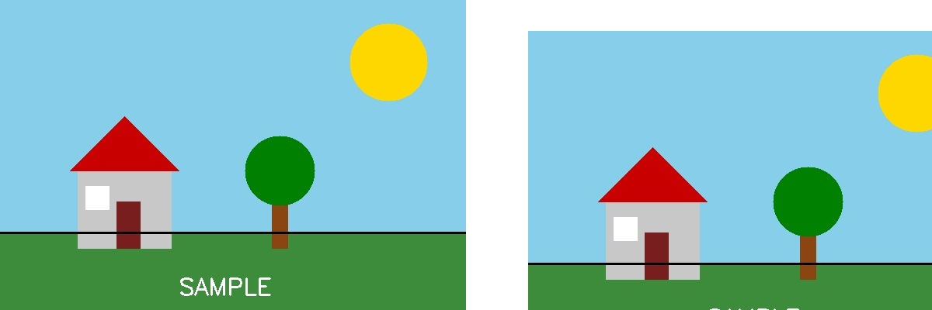

Experiment 11: Affine Transformation on an Image
Aim:
To apply an Affine Transformation to an image, which preserves parallel lines while changing position, scale, and shear.
Algorithm:
1. Import OpenCV and NumPy.
2. Read the input image and note its dimensions.
3. Select 3 reference points in the source image (pts1).
4. Define where those 3 points should map to in the output image (pts2).
5. Compute the affine transformation matrix using cv2.getAffineTransform(pts1, pts2).
6. Apply the matrix with cv2.warpAffine().
7. Display and save the transformed image.
Program (Python):
import cv2
import numpy as np

img = cv2.imread("image.jpg")
(h, w) = img.shape[:2]

pts1 = np.float32([[50, 50], [200, 50], [50, 200]])
pts2 = np.float32([[10, 100], [200, 50], [100, 250]])

M = cv2.getAffineTransform(pts1, pts2)
affine_result = cv2.warpAffine(img, M, (w, h))

cv2.imshow("Original", img)
cv2.imshow("Affine Transformed", affine_result)
cv2.waitKey(0)
cv2.destroyAllWindows()
Output:
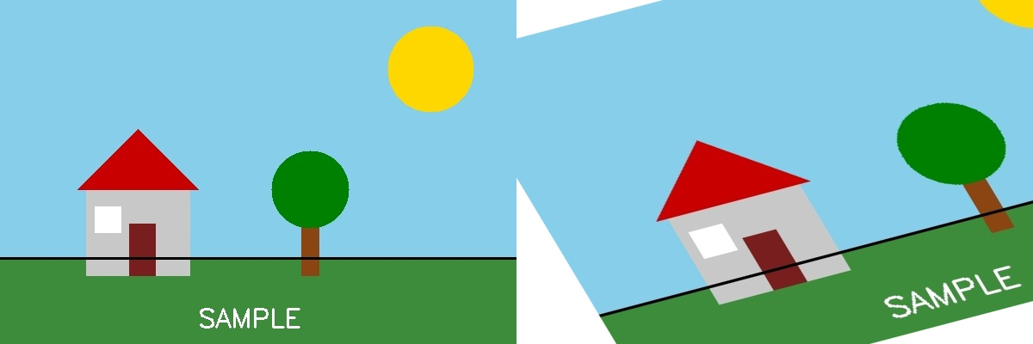

Experiment 12: Perspective Transformation on an Image
Aim:
To apply a Perspective Transformation to an image to simulate a change in viewing angle (does not preserve parallel lines).
Algorithm:
1. Import OpenCV and NumPy.
2. Read the input image and note its dimensions.
3. Select 4 reference points in the source image (the four corners).
4. Define the 4 corresponding destination points.
5. Compute the perspective transform matrix using cv2.getPerspectiveTransform().
6. Apply the matrix with cv2.warpPerspective().
7. Display and save the transformed image.
Program (Python):
import cv2
import numpy as np

img = cv2.imread("image.jpg")
(h, w) = img.shape[:2]

pts1 = np.float32([[0, 0], [w, 0], [0, h], [w, h]])
pts2 = np.float32([[50, 50], [w-100, 30], [50, h-30], [w-50, h-100]])

M = cv2.getPerspectiveTransform(pts1, pts2)
perspective_result = cv2.warpPerspective(img, M, (w, h))

cv2.imshow("Original", img)
cv2.imshow("Perspective Transformed", perspective_result)
cv2.waitKey(0)
cv2.destroyAllWindows()
Output:
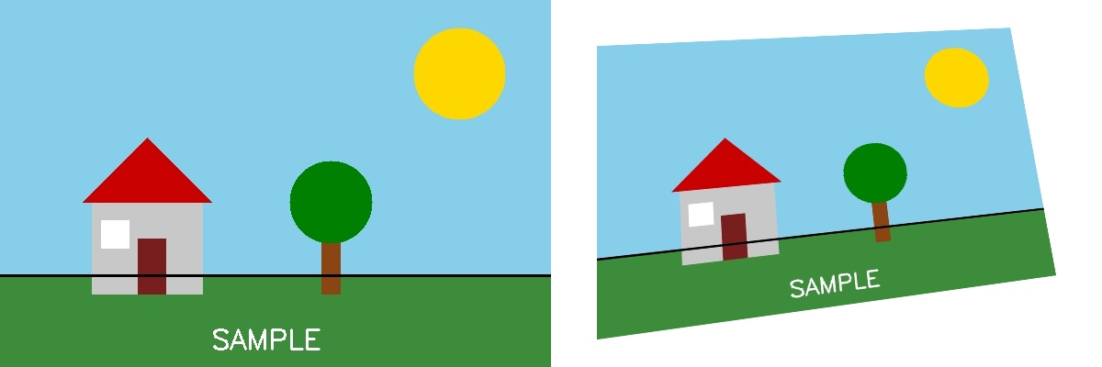

Experiment 13: Perspective Transformation on a Video
Aim:
To apply a Perspective Transformation to every frame of a video in real time.
Algorithm:
1. Import OpenCV and NumPy.
2. Open the video using cv2.VideoCapture().
3. Read the first frame to get the frame dimensions.
4. Define source and destination points and compute the perspective matrix once.
5. Loop through each frame: read the frame, apply cv2.warpPerspective() using the matrix.
6. Display the warped frame; break on 'q' key.
7. Release the capture and close windows.
Program (Python):
import cv2
import numpy as np

cap = cv2.VideoCapture("input_video.mp4")
ret, frame = cap.read()
(h, w) = frame.shape[:2]

pts1 = np.float32([[0, 0], [w, 0], [0, h], [w, h]])
pts2 = np.float32([[50, 50], [w-100, 30], [50, h-30], [w-50, h-100]])
M = cv2.getPerspectiveTransform(pts1, pts2)

while cap.isOpened():
ret, frame = cap.read()
if not ret:
break
warped = cv2.warpPerspective(frame, M, (w, h))
cv2.imshow("Perspective Transformed Video", warped)
if cv2.waitKey(25) & 0xFF == ord('q'):
break

cap.release()
cv2.destroyAllWindows()
Output:
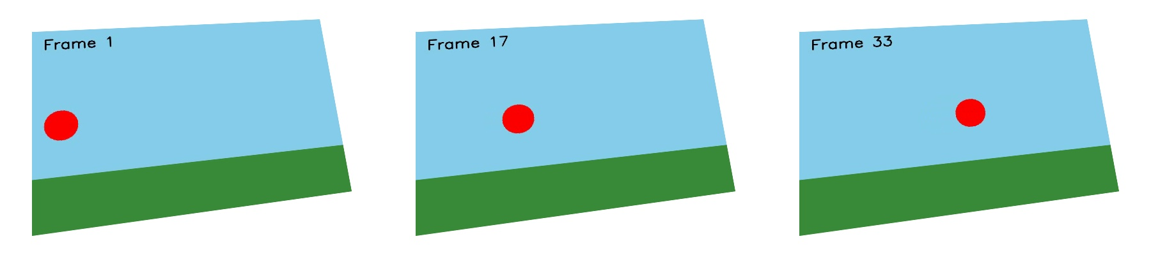
Perspective-warped video frames shown in sequence.

Experiment 14: Transformation using Homography Matrix
Aim:
To compute a Homography matrix from point correspondences and use it to warp an image.
Algorithm:
1. Import OpenCV and NumPy.
2. Read the input image and note its dimensions.
3. Define at least 4 source points and their corresponding destination points.
4. Compute the homography matrix using cv2.findHomography(pts_src, pts_dst).
5. Apply the homography with cv2.warpPerspective().
6. Display and save the transformed image.
Program (Python):
import cv2
import numpy as np

img = cv2.imread("image.jpg")
(h, w) = img.shape[:2]

pts_src = np.array([[0, 0], [w-1, 0], [w-1, h-1], [0, h-1]])
pts_dst = np.array([[50, 50], [w-100, 30], [w-50, h-60], [80, h-40]])

H, status = cv2.findHomography(pts_src, pts_dst)
homography_result = cv2.warpPerspective(img, H, (w, h))

cv2.imshow("Original", img)
cv2.imshow("Homography Transformed", homography_result)
cv2.waitKey(0)
cv2.destroyAllWindows()
Output:
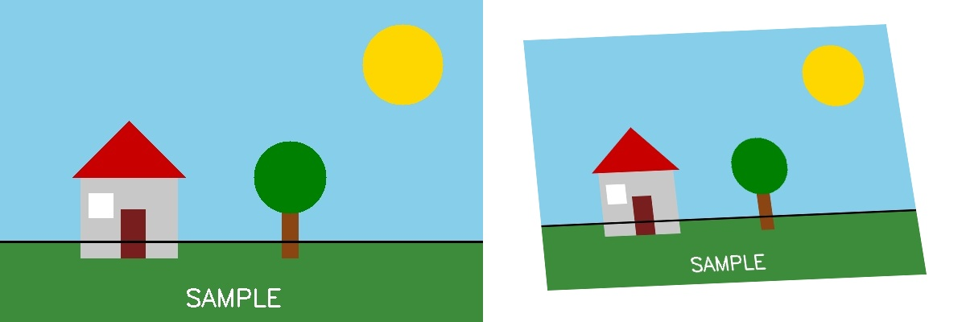

Experiment 15: Transformation using Direct Linear Transformation (DLT)
Aim:
To manually compute a homography matrix using the Direct Linear Transformation algorithm (the method OpenCV uses internally) and apply it to warp an image.
Algorithm:
1. Import OpenCV and NumPy.
2. For each of the 4 point correspondences (source x,y and destination u,v), build two rows of the matrix A using the DLT equations.
3. Stack all rows to form matrix A.
4. Perform Singular Value Decomposition (SVD) on A.
5. The homography H is the last row of V^T (the singular vector for the smallest singular value), reshaped into a 3x3 matrix.
6. Normalize H by dividing by H[2,2].
7. Apply H to the image using cv2.warpPerspective().
Program (Python):
import cv2
import numpy as np

def compute_dlt_homography(pts_src, pts_dst):
A = []
for i in range(len(pts_src)):
x, y = pts_src[i][0], pts_src[i][1]
u, v = pts_dst[i][0], pts_dst[i][1]
A.append([-x, -y, -1, 0, 0, 0, x*u, y*u, u])
A.append([0, 0, 0, -x, -y, -1, x*v, y*v, v])
A = np.array(A)
_, _, Vt = np.linalg.svd(A)
H = Vt[-1].reshape(3, 3)
return H / H[2, 2]

img = cv2.imread("image.jpg")
(h, w) = img.shape[:2]

pts_src = np.array([[0,0],[w-1,0],[w-1,h-1],[0,h-1]], dtype=np.float32)
pts_dst = np.array([[50,50],[w-100,30],[w-50,h-60],[80,h-40]], dtype=np.float32)

H = compute_dlt_homography(pts_src, pts_dst)
dlt_result = cv2.warpPerspective(img, H, (w, h))

cv2.imshow("Original", img)
cv2.imshow("DLT Transformed", dlt_result)
cv2.waitKey(0)
cv2.destroyAllWindows()
Output:


Experiment 16: Edge Detection using Canny Method
Aim:
To detect edges in an image using the Canny edge detection algorithm.
Algorithm:
1. Import OpenCV.
2. Read the input image and convert it to grayscale.
3. Apply cv2.Canny() with lower and upper hysteresis thresholds.
4. Display and save the resulting edge map.
Program (Python):
import cv2

img = cv2.imread("image.jpg")
gray = cv2.cvtColor(img, cv2.COLOR_BGR2GRAY)

edges = cv2.Canny(gray, 100, 200)

cv2.imshow("Canny Edges", edges)
cv2.waitKey(0)
cv2.destroyAllWindows()
Output:


Experiment 17: Edge Detection using Sobel Matrix along X axis
Aim:
To detect vertical edges in an image using the Sobel operator along the X direction.
Algorithm:
1. Import OpenCV.
2. Read the image and convert it to grayscale.
3. Apply cv2.Sobel() with dx=1, dy=0 to compute the gradient along the X axis.
4. Convert the result back to an 8-bit displayable image using cv2.convertScaleAbs().
5. Display and save the Sobel-X edge image.
Program (Python):
import cv2

img = cv2.imread("image.jpg")
gray = cv2.cvtColor(img, cv2.COLOR_BGR2GRAY)

sobel_x = cv2.Sobel(gray, cv2.CV_64F, 1, 0, ksize=3)
sobel_x = cv2.convertScaleAbs(sobel_x)

cv2.imshow("Sobel X", sobel_x)
cv2.waitKey(0)
cv2.destroyAllWindows()
Output:
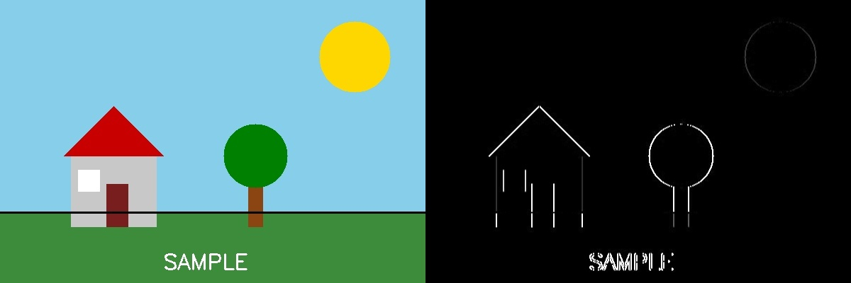

Experiment 18: Edge Detection using Sobel Matrix along Y axis
Aim:
To detect horizontal edges in an image using the Sobel operator along the Y direction.
Algorithm:
1. Import OpenCV.
2. Read the image and convert it to grayscale.
3. Apply cv2.Sobel() with dx=0, dy=1 to compute the gradient along the Y axis.
4. Convert the result back to an 8-bit displayable image using cv2.convertScaleAbs().
5. Display and save the Sobel-Y edge image.
Program (Python):
import cv2

img = cv2.imread("image.jpg")
gray = cv2.cvtColor(img, cv2.COLOR_BGR2GRAY)

sobel_y = cv2.Sobel(gray, cv2.CV_64F, 0, 1, ksize=3)
sobel_y = cv2.convertScaleAbs(sobel_y)

cv2.imshow("Sobel Y", sobel_y)
cv2.waitKey(0)
cv2.destroyAllWindows()
Output:
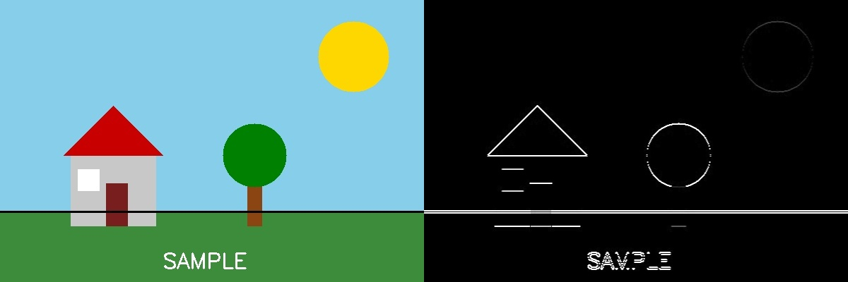

Experiment 19: Edge Detection using Sobel Matrix along XY axis (Combined)
Aim:
To detect edges in both X and Y directions and combine them to get the overall edge magnitude using the Sobel operator.
Algorithm:
1. Import OpenCV.
2. Read the image and convert it to grayscale.
3. Compute the Sobel gradient along the X axis (dx=1, dy=0).
4. Compute the Sobel gradient along the Y axis (dx=0, dy=1).
5. Combine both gradients using cv2.magnitude() to get the overall edge strength.
6. Convert the result to 8-bit using cv2.convertScaleAbs().
7. Display and save the combined Sobel-XY edge image.
Program (Python):
import cv2

img = cv2.imread("image.jpg")
gray = cv2.cvtColor(img, cv2.COLOR_BGR2GRAY)

sobel_x = cv2.Sobel(gray, cv2.CV_64F, 1, 0, ksize=3)
sobel_y = cv2.Sobel(gray, cv2.CV_64F, 0, 1, ksize=3)

# Combine both directions
sobel_xy = cv2.magnitude(sobel_x, sobel_y)
sobel_xy = cv2.convertScaleAbs(sobel_xy)

cv2.imshow("Sobel XY (Combined)", sobel_xy)
cv2.waitKey(0)
cv2.destroyAllWindows()
Output:
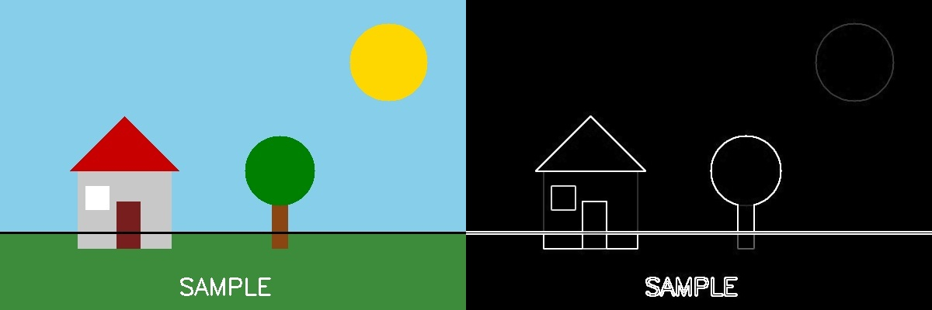

Experiment 20: Sharpening of Image using Laplacian Mask with Negative Center Coefficient
Aim:
To sharpen an image by convolving it with a Laplacian mask whose center coefficient is negative, then subtracting the result from the original image.
Algorithm:
1. Import OpenCV and NumPy.
2. Read the input image.
3. Define the Laplacian kernel [[0,1,0],[1,-4,1],[0,1,0]] (negative center).
4. Apply cv2.filter2D() with this kernel to get the Laplacian (edge) response.
5. Since the center is negative, sharpen using: sharpened = original - laplacian.
6. Clip pixel values to the valid range [0,255] and convert to uint8.
7. Display and save the sharpened image.
Program (Python):
import cv2
import numpy as np

img = cv2.imread("image.jpg")

kernel = np.array([[0, 1, 0],
[1, -4, 1],
[0, 1, 0]])

laplacian = cv2.filter2D(img, cv2.CV_64F, kernel)
sharpened = np.clip(img.astype(np.float64) - laplacian, 0, 255).astype(np.uint8)

cv2.imshow("Sharpened (Negative Center)", sharpened)
cv2.waitKey(0)
cv2.destroyAllWindows()
Output:
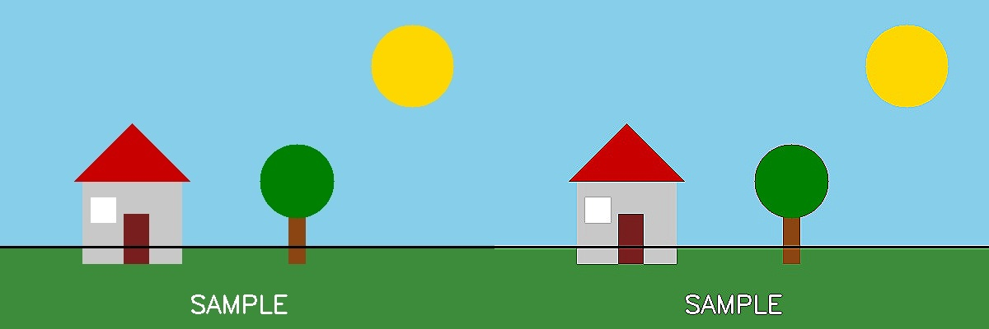

Experiment 21: Sharpening using Laplacian Mask Extended with Diagonal Neighbors
Aim:
To sharpen an image using an extended 3x3 Laplacian mask that also includes the four diagonal neighbors (8-connected Laplacian).
Algorithm:
1. Import OpenCV and NumPy.
2. Read the input image.
3. Define the extended Laplacian kernel [[1,1,1],[1,-8,1],[1,1,1]] which includes diagonal neighbors.
4. Apply cv2.filter2D() with this kernel.
5. Subtract the Laplacian response from the original image to sharpen it.
6. Clip values to [0,255] and convert to uint8.
7. Display and save the result.
Program (Python):
import cv2
import numpy as np

img = cv2.imread("image.jpg")

kernel = np.array([[1, 1, 1],
[1, -8, 1],
[1, 1, 1]])

laplacian = cv2.filter2D(img, cv2.CV_64F, kernel)
sharpened = np.clip(img.astype(np.float64) - laplacian, 0, 255).astype(np.uint8)

cv2.imshow("Sharpened (Diagonal Neighbors)", sharpened)
cv2.waitKey(0)
cv2.destroyAllWindows()
Output:
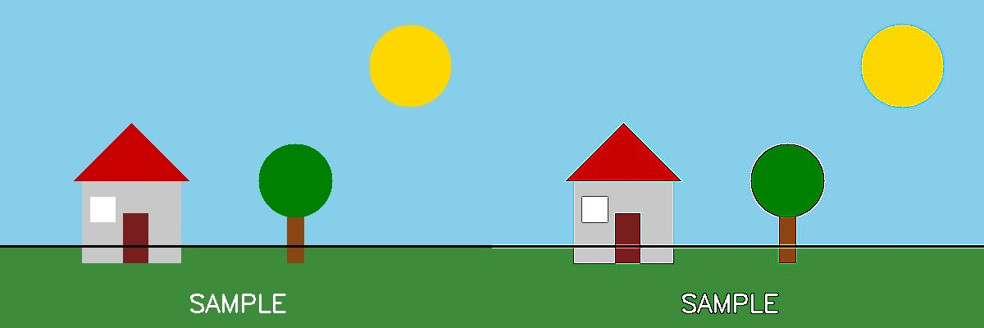

Experiment 22: Sharpening using Laplacian Mask with Positive Center Coefficient
Aim:
To sharpen an image using a Laplacian mask with a positive center coefficient, where the addition of the original image is already built into the mask.
Algorithm:
1. Import OpenCV and NumPy.
2. Read the input image.
3. Define the composite kernel [[0,-1,0],[-1,5,-1],[0,-1,0]] — this already represents g(x,y) = f(x,y) + Laplacian, since the center coefficient (5) is positive.
4. Apply cv2.filter2D() directly with this kernel (no separate subtraction/addition needed).
5. Display and save the sharpened image.
Program (Python):
import cv2
import numpy as np

img = cv2.imread("image.jpg")

# Positive-center Laplacian mask (addition already built in)
kernel = np.array([[0, -1, 0],
[-1, 5, -1],
[0, -1, 0]])

sharpened = cv2.filter2D(img, -1, kernel)

cv2.imshow("Sharpened (Positive Center)", sharpened)
cv2.waitKey(0)
cv2.destroyAllWindows()
Output:


Experiment 23: Sharpening of Image using Unsharp Masking
Aim:
To sharpen an image using Unsharp Masking, where a blurred version of the image is subtracted from the original to enhance edges.
Algorithm:
1. Import OpenCV.
2. Read the input image.
3. Create a blurred version of the image using cv2.GaussianBlur().
4. Compute the sharpened image using the formula: sharpened = original + k*(original - blurred), implemented via cv2.addWeighted() with weights (e.g. 1.5 on original, -0.5 on blurred).
5. Display and save the sharpened image.
Program (Python):
import cv2

img = cv2.imread("image.jpg")

# Step 1: Create a blurred version
blurred = cv2.GaussianBlur(img, (9, 9), 10)

# Step 2: sharpened = original - blurred (weighted)
sharpened = cv2.addWeighted(img, 1.5, blurred, -0.5, 0)

cv2.imshow("Unsharp Masking Result", sharpened)
cv2.waitKey(0)
cv2.destroyAllWindows()
Output:
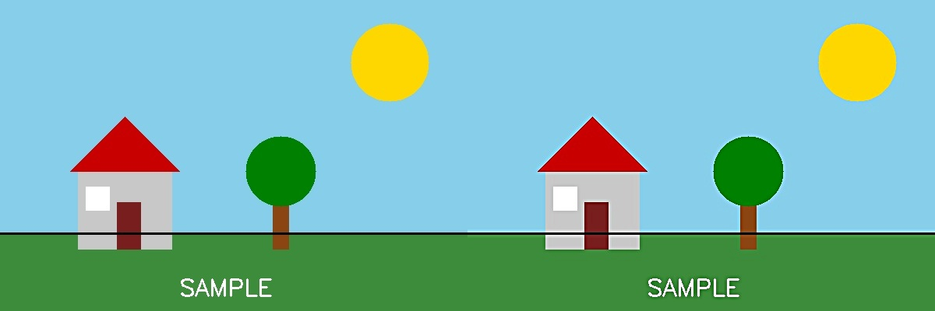

Experiment 24: Sharpening of Image using High-Boost Masks
Aim:
To sharpen an image using a High-Boost filter, which amplifies the original image before subtracting the blurred/low-pass component, giving control over the amount of sharpening (A >= 1).
Algorithm:
1. Import OpenCV and NumPy.
2. Read the input image.
3. Choose a boost factor A (A >= 1; A = 1 reduces to standard Laplacian sharpening).
4. Build the high-boost kernel [[0,-1,0],[-1,A+4,-1],[0,-1,0]].
5. Apply cv2.filter2D() with this kernel.
6. Display and save the high-boost sharpened image.
Program (Python):
import cv2
import numpy as np

img = cv2.imread("image.jpg")

A = 1.5 # Boost factor (A >= 1)
kernel = np.array([[0, -1, 0],
[-1, A + 4, -1],
[0, -1, 0]])

sharpened = cv2.filter2D(img, -1, kernel)

cv2.imshow("High-Boost Sharpened", sharpened)
cv2.waitKey(0)
cv2.destroyAllWindows()
Output:
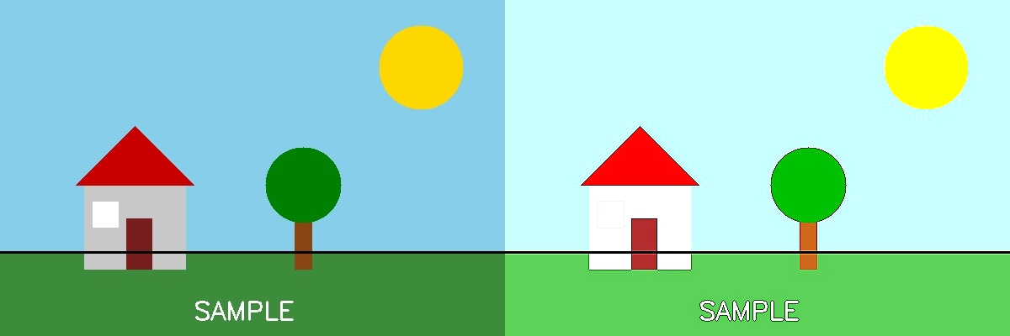

Experiment 25: Sharpening of Image using Gradient Masking
Aim:
To sharpen/enhance edges of an image using gradient-based masks (Sobel-type kernels) that highlight the rate of intensity change.
Algorithm:
1. Import OpenCV and NumPy.
2. Read the input image.
3. Define gradient kernels for X and Y directions (Sobel-like 3x3 masks).
4. Convolve the image with both kernels using cv2.filter2D().
5. Compute the gradient magnitude by combining both directional responses.
6. Blend the gradient magnitude with the original image to enhance edges.
7. Display and save the result.
Program (Python):
import cv2
import numpy as np

img = cv2.imread("image.jpg")

kx = np.array([[-1, -2, -1], [0, 0, 0], [1, 2, 1]])
ky = np.array([[-1, 0, 1], [-2, 0, 2], [-1, 0, 1]])

gx = cv2.filter2D(img, cv2.CV_64F, kx)
gy = cv2.filter2D(img, cv2.CV_64F, ky)

gradient = cv2.magnitude(gx[:, :, 0], gy[:, :, 0])
gradient = cv2.convertScaleAbs(gradient)
gradient_color = cv2.cvtColor(gradient, cv2.COLOR_GRAY2BGR)

sharpened = cv2.addWeighted(img, 1.0, gradient_color, 0.5, 0)

cv2.imshow("Gradient Masked Sharpening", sharpened)
cv2.waitKey(0)
cv2.destroyAllWindows()
Output:
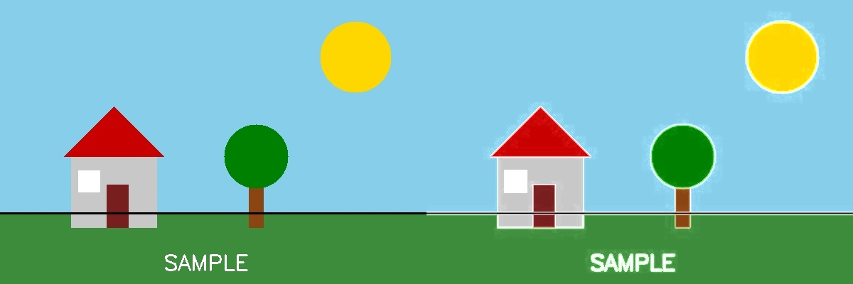

Experiment 26: Insert Watermarking to the Image using OpenCV
Aim:
To overlay a semi-transparent text watermark onto an image using OpenCV.
Algorithm:
1. Import OpenCV.
2. Read the input image.
3. Create a copy of the image as an overlay layer.
4. Draw the watermark text onto the overlay using cv2.putText().
5. Blend the overlay with the original image using cv2.addWeighted() to make the watermark semi-transparent.
6. Display and save the watermarked image.
Program (Python):
import cv2

img = cv2.imread("image.jpg")
overlay = img.copy()

h, w = img.shape[:2]
cv2.putText(overlay, "SAMPLE WATERMARK", (60, h - 30),
cv2.FONT_HERSHEY_SIMPLEX, 1, (255, 255, 255), 2, cv2.LINE_AA)

# Blend overlay with original for transparency effect
watermarked = cv2.addWeighted(overlay, 0.4, img, 0.6, 0)

cv2.imwrite("watermarked_output.jpg", watermarked)
cv2.imshow("Watermarked Image", watermarked)
cv2.waitKey(0)
cv2.destroyAllWindows()
Output:
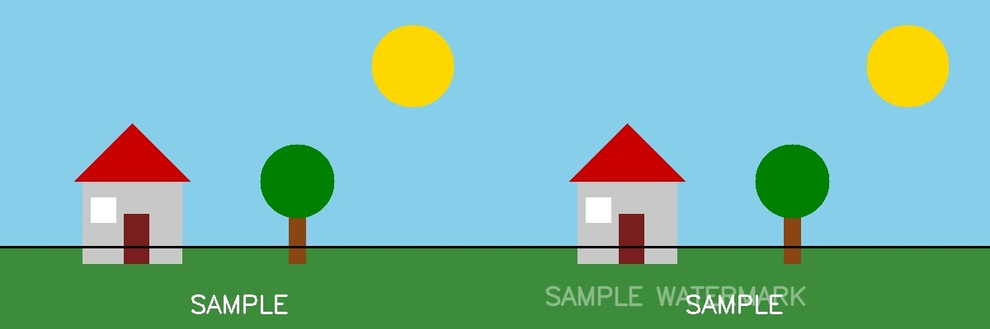

Experiment 27: Cropping, Copying and Pasting an Image inside Another Image using OpenCV
Aim:
To crop a region from one image and paste (copy) it onto another image at a specified location using array slicing.
Algorithm:
1. Import OpenCV and NumPy.
2. Read the source image.
3. Crop the desired region using array slicing: crop = img[y1:y2, x1:x2].
4. Create or read the destination/base image.
5. Paste the cropped region into the destination image using slice assignment: base[y:y+h, x:x+w] = crop.
6. Display and save the resulting composite image.
Program (Python):
import cv2
import numpy as np

img = cv2.imread("image.jpg")
base = cv2.imread("background.jpg") # destination image

# Crop a region from the source image
crop = img[150:320, 300:470]

# Paste the cropped region onto the base image at (40, 40)
pasted = base.copy()
pasted[40:40 + crop.shape[0], 40:40 + crop.shape[1]] = crop

cv2.imwrite("crop_paste_output.jpg", pasted)
cv2.imshow("Cropped and Pasted", pasted)
cv2.waitKey(0)
cv2.destroyAllWindows()
Output:
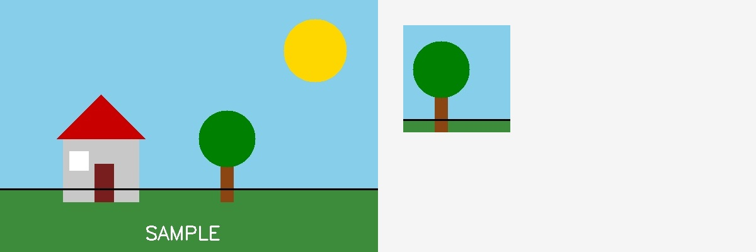

Experiment 28: Find the Boundary of the Image using Convolution Kernel
Aim:
To extract the boundary (outline) of objects in an image by convolving it with a boundary-detection kernel.
Algorithm:
1. Import OpenCV and NumPy.
2. Read the input image and convert it to grayscale.
3. Define a boundary-detection kernel [[-1,-1,-1],[-1,8,-1],[-1,-1,-1]] (sums to zero, so flat regions become 0 and edges are highlighted).
4. Apply cv2.filter2D() with this kernel on the grayscale image.
5. Display and save the boundary image.
Program (Python):
import cv2
import numpy as np

img = cv2.imread("image.jpg")
gray = cv2.cvtColor(img, cv2.COLOR_BGR2GRAY)

kernel = np.array([[-1, -1, -1],
[-1, 8, -1],
[-1, -1, -1]])

boundary = cv2.filter2D(gray, -1, kernel)

cv2.imshow("Boundary Detected", boundary)
cv2.waitKey(0)
cv2.destroyAllWindows()
Output:
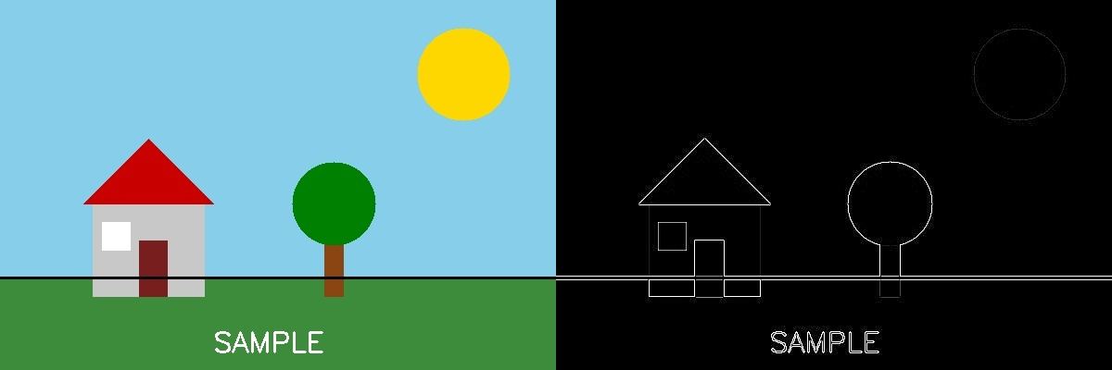

Experiment 29: Morphological Operations using OpenCV — Erosion Technique
Aim:
To apply the morphological Erosion operation on a binary image to shrink white foreground regions and remove small noise.
Algorithm:
1. Import OpenCV and NumPy.
2. Read the input image, convert to grayscale, and threshold it to get a binary image.
3. Define a structuring element (kernel).
4. Apply cv2.erode() on the binary image.
5. Display and save the eroded result.
Program (Python):
import cv2
import numpy as np

img = cv2.imread("image.jpg")
gray = cv2.cvtColor(img, cv2.COLOR_BGR2GRAY)
_, binary = cv2.threshold(gray, 120, 255, cv2.THRESH_BINARY)

kernel = np.ones((5, 5), np.uint8)
erosion = cv2.erode(binary, kernel, iterations=1)

cv2.imshow("Erosion", erosion)
cv2.waitKey(0)
cv2.destroyAllWindows()
Output:
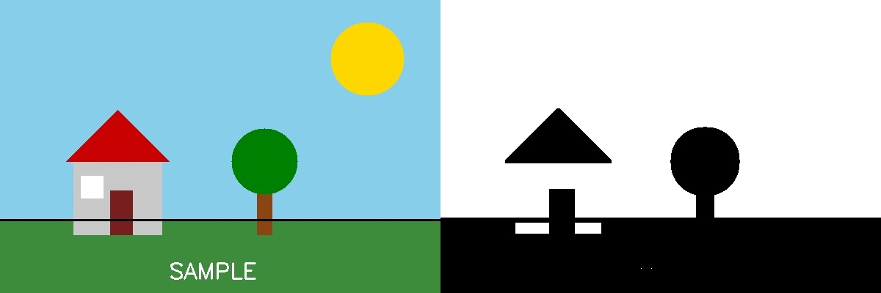

Experiment 30: Morphological Operations using OpenCV — Dilation Technique
Aim:
To apply the morphological Dilation operation on a binary image to expand white foreground regions and fill small holes.
Algorithm:
1. Import OpenCV and NumPy.
2. Read the input image, convert to grayscale, and threshold it to get a binary image.
3. Define a structuring element (kernel).
4. Apply cv2.dilate() on the binary image.
5. Display and save the dilated result.
Program (Python):
import cv2
import numpy as np

img = cv2.imread("image.jpg")
gray = cv2.cvtColor(img, cv2.COLOR_BGR2GRAY)
_, binary = cv2.threshold(gray, 120, 255, cv2.THRESH_BINARY)

kernel = np.ones((5, 5), np.uint8)
dilation = cv2.dilate(binary, kernel, iterations=1)

cv2.imshow("Dilation", dilation)
cv2.waitKey(0)
cv2.destroyAllWindows()
Output:
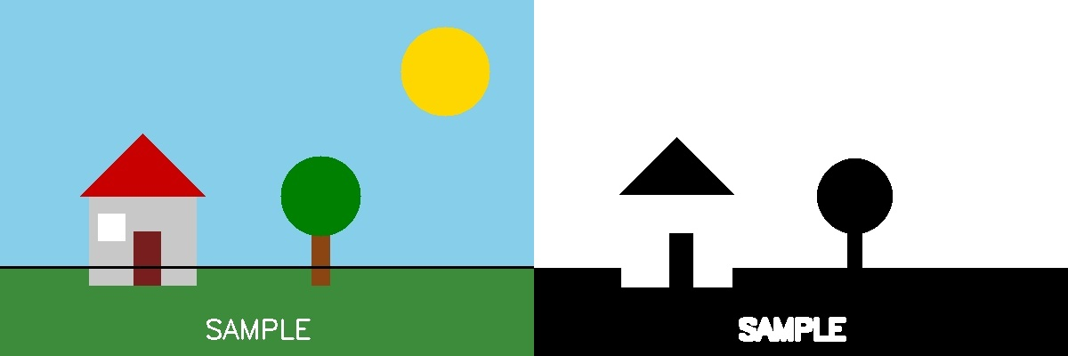

Experiment 31: Morphological Operations using OpenCV — Opening Technique
Aim:
To apply the morphological Opening operation (erosion followed by dilation) to remove small noise/specks while preserving the shape and size of larger objects.
Algorithm:
1. Import OpenCV and NumPy.
2. Read the input image, convert to grayscale, and threshold it to get a binary image.
3. Define a structuring element (kernel).
4. Apply cv2.morphologyEx() with the flag cv2.MORPH_OPEN.
5. Display and save the opened result.
Program (Python):
import cv2
import numpy as np

img = cv2.imread("image.jpg")
gray = cv2.cvtColor(img, cv2.COLOR_BGR2GRAY)
_, binary = cv2.threshold(gray, 120, 255, cv2.THRESH_BINARY)

kernel = np.ones((5, 5), np.uint8)
opening = cv2.morphologyEx(binary, cv2.MORPH_OPEN, kernel)

cv2.imshow("Opening", opening)
cv2.waitKey(0)
cv2.destroyAllWindows()
Output:
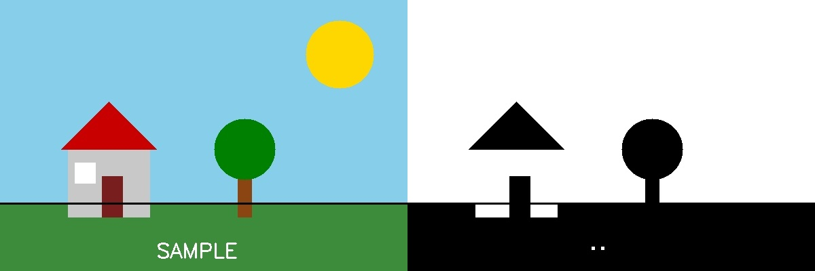

Experiment 32: Morphological Operations using OpenCV — Closing Technique
Aim:
To apply the morphological Closing operation (dilation followed by erosion) to fill small holes and gaps inside foreground objects.
Algorithm:
1. Import OpenCV and NumPy.
2. Read the input image, convert to grayscale, and threshold it to get a binary image.
3. Define a structuring element (kernel).
4. Apply cv2.morphologyEx() with the flag cv2.MORPH_CLOSE.
5. Display and save the closed result.
Program (Python):
import cv2
import numpy as np

img = cv2.imread("image.jpg")
gray = cv2.cvtColor(img, cv2.COLOR_BGR2GRAY)
_, binary = cv2.threshold(gray, 120, 255, cv2.THRESH_BINARY)

kernel = np.ones((5, 5), np.uint8)
closing = cv2.morphologyEx(binary, cv2.MORPH_CLOSE, kernel)

cv2.imshow("Closing", closing)
cv2.waitKey(0)
cv2.destroyAllWindows()
Output:
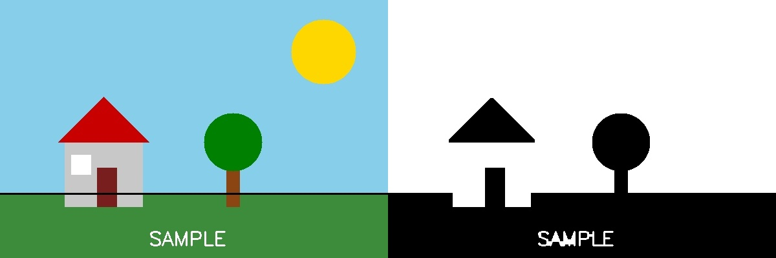

Experiment 33: Morphological Operations using OpenCV — Morphological Gradient Technique
Aim:
To compute the Morphological Gradient (difference between Dilation and Erosion) of an image, which highlights object boundaries.
Algorithm:
1. Import OpenCV and NumPy.
2. Read the input image, convert to grayscale, and threshold it to get a binary image.
3. Define a structuring element (kernel).
4. Apply cv2.morphologyEx() with the flag cv2.MORPH_GRADIENT (this computes dilation - erosion internally).
5. Display and save the result showing object outlines.
Program (Python):
import cv2
import numpy as np

img = cv2.imread("image.jpg")
gray = cv2.cvtColor(img, cv2.COLOR_BGR2GRAY)
_, binary = cv2.threshold(gray, 120, 255, cv2.THRESH_BINARY)

kernel = np.ones((5, 5), np.uint8)
gradient = cv2.morphologyEx(binary, cv2.MORPH_GRADIENT, kernel)

cv2.imshow("Morphological Gradient", gradient)
cv2.waitKey(0)
cv2.destroyAllWindows()
Output:
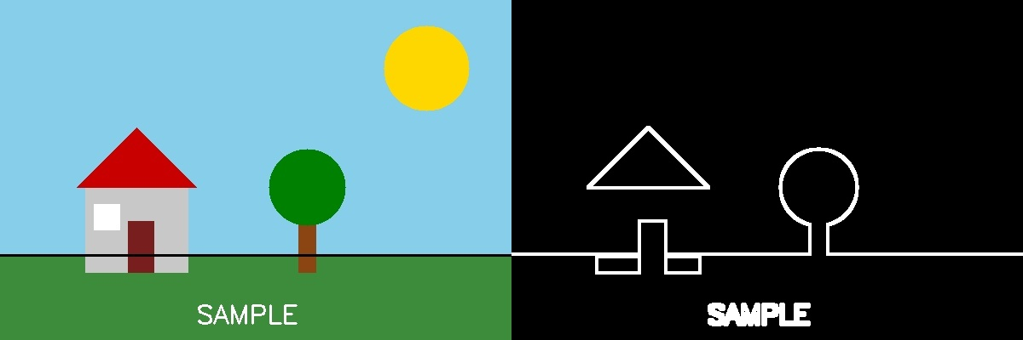

Experiment 34: Morphological Operations using OpenCV — Top Hat Technique
Aim:
To compute the Top Hat transform (difference between the input image and its Opening), which highlights small bright details/objects on a dark background.
Algorithm:
1. Import OpenCV and NumPy.
2. Read the input image, convert to grayscale, and threshold it to get a binary image.
3. Define a structuring element (kernel).
4. Apply cv2.morphologyEx() with the flag cv2.MORPH_TOPHAT.
5. Display and save the resulting Top Hat image.
Program (Python):
import cv2
import numpy as np

img = cv2.imread("image.jpg")
gray = cv2.cvtColor(img, cv2.COLOR_BGR2GRAY)
_, binary = cv2.threshold(gray, 120, 255, cv2.THRESH_BINARY)

kernel = np.ones((9, 9), np.uint8)
tophat = cv2.morphologyEx(binary, cv2.MORPH_TOPHAT, kernel)

cv2.imshow("Top Hat", tophat)
cv2.waitKey(0)
cv2.destroyAllWindows()
Output:
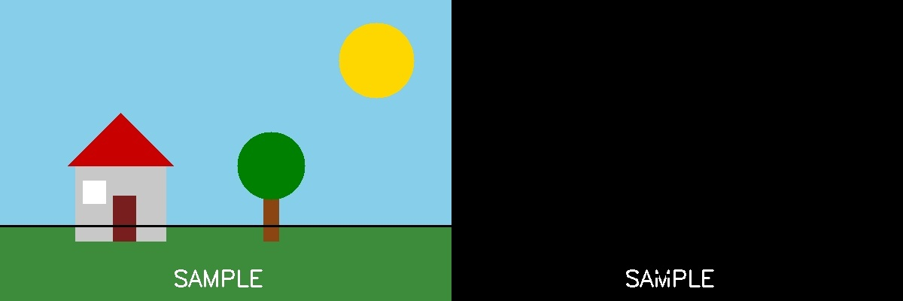

Experiment 35: Morphological Operations using OpenCV — Black Hat Technique
Aim:
To compute the Black Hat transform (difference between the Closing of the image and the input image), which highlights small dark details/holes on a bright background.
Algorithm:
1. Import OpenCV and NumPy.
2. Read the input image, convert to grayscale, and threshold it to get a binary image.
3. Define a structuring element (kernel).
4. Apply cv2.morphologyEx() with the flag cv2.MORPH_BLACKHAT.
5. Display and save the resulting Black Hat image.
Program (Python):
import cv2
import numpy as np

img = cv2.imread("image.jpg")
gray = cv2.cvtColor(img, cv2.COLOR_BGR2GRAY)
_, binary = cv2.threshold(gray, 120, 255, cv2.THRESH_BINARY)

kernel = np.ones((9, 9), np.uint8)
blackhat = cv2.morphologyEx(binary, cv2.MORPH_BLACKHAT, kernel)

cv2.imshow("Black Hat", blackhat)
cv2.waitKey(0)
cv2.destroyAllWindows()
Output:
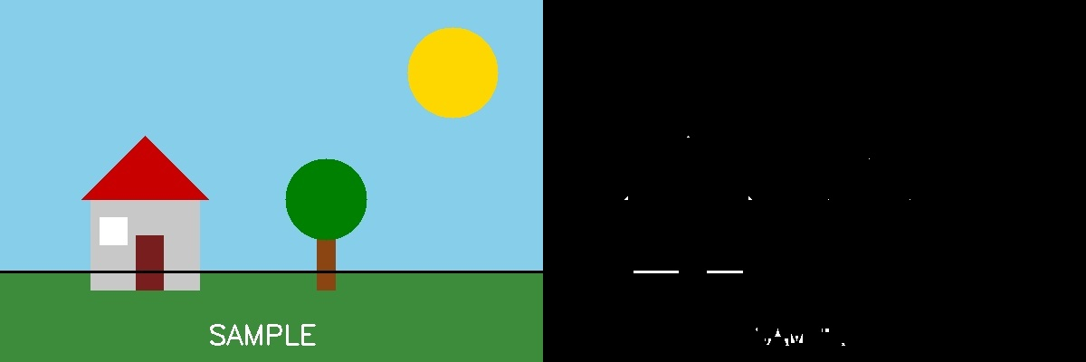

Experiment 36: Recognize an Object from an Image using General Object Recognition (Template Matching)
Aim:
To recognize/locate a known object (e.g. a watch) within a larger image using OpenCV's template matching technique.
Algorithm:
1. Import OpenCV.
2. Read the main (source) image and the template image of the object to be found.
3. Apply cv2.matchTemplate() using a similarity method such as cv2.TM_CCOEFF_NORMED.
4. Use cv2.minMaxLoc() to find the location with the highest match score.
5. Draw a rectangle at the matched location using the template's width and height.
6. Display and save the image with the recognized object highlighted.
Program (Python):
import cv2

img = cv2.imread("scene.jpg")
template = cv2.imread("watch_template.jpg")
th, tw = template.shape[:2]

# Template Matching
result = cv2.matchTemplate(img, template, cv2.TM_CCOEFF_NORMED)
_, max_val, _, max_loc = cv2.minMaxLoc(result)

top_left = max_loc
bottom_right = (top_left[0] + tw, top_left[1] + th)
cv2.rectangle(img, top_left, bottom_right, (0, 0, 255), 3)

cv2.putText(img, f"Match: {max_val:.2f}", (top_left[0], top_left[1]-10),
cv2.FONT_HERSHEY_SIMPLEX, 0.6, (0, 0, 255), 2)

cv2.imshow("Recognized Object", img)
cv2.waitKey(0)
cv2.destroyAllWindows()
Output:
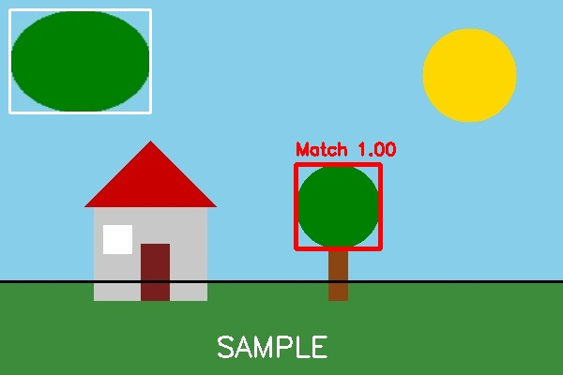
Small inset (top-left) is the template being searched for; the red box shows the best-matching location found in the scene.

Experiment 37: Using OpenCV, Play Video in Reverse Mode
Aim:
To read a video, store all its frames, and play them back in reverse order using OpenCV.
Algorithm:
1. Import OpenCV.
2. Open the video using cv2.VideoCapture().
3. Read all frames in a loop and store them in a list.
4. Reverse the list of frames using slicing frames[::-1].
5. Loop through the reversed list and display each frame using cv2.imshow().
6. Optionally write the reversed frames to a new output video using cv2.VideoWriter().
7. Release resources and close windows.
Program (Python):
import cv2

cap = cv2.VideoCapture("input_video.mp4")
frames = []

while True:
ret, frame = cap.read()
if not ret:
break
frames.append(frame)
cap.release()

# Reverse the order of frames
reversed_frames = frames[::-1]

for frame in reversed_frames:
cv2.imshow("Reverse Playback", frame)
if cv2.waitKey(30) & 0xFF == ord('q'):
break

cv2.destroyAllWindows()

# Optional: save the reversed video to a file
h, w = frames[0].shape[:2]
fourcc = cv2.VideoWriter_fourcc(*'mp4v')
out = cv2.VideoWriter("reversed_output.mp4", fourcc, 20, (w, h))
for frame in reversed_frames:
out.write(frame)
out.release()
Output:
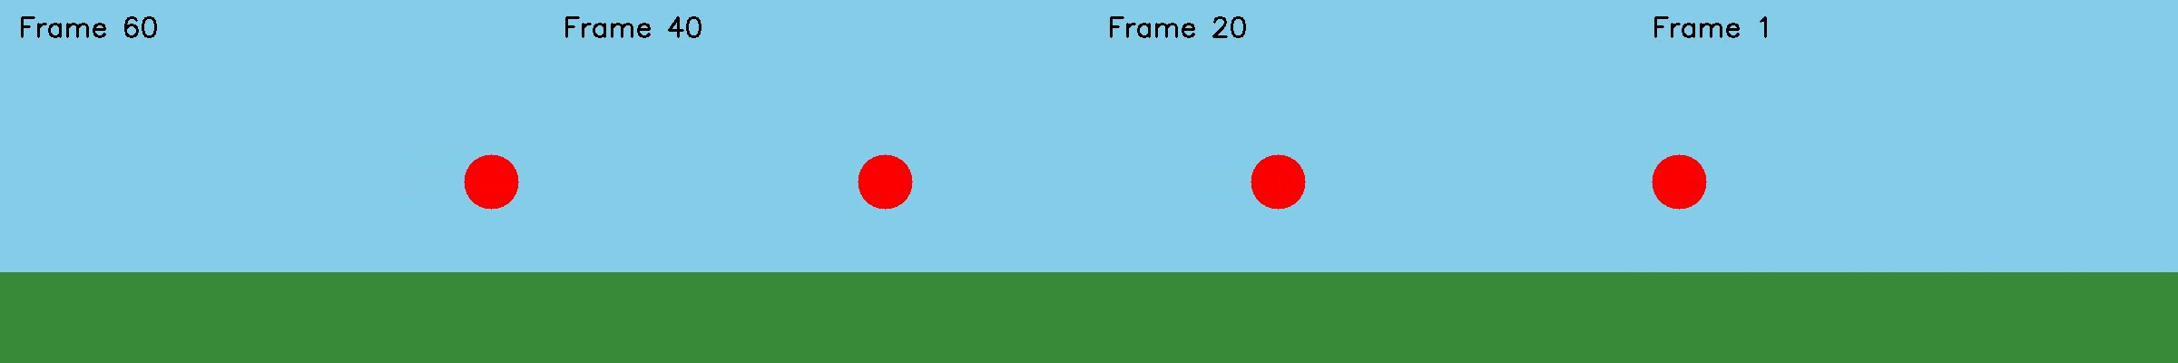
Sample frames shown in reverse playback order (left = last original frame, right = first original frame).

Experiment 38: Face Detection using OpenCV
Aim:
To detect human faces in an image using OpenCV's Haar Cascade Classifier.
Algorithm:
1. Import OpenCV.
2. Read the input image and convert it to grayscale.
3. Load a pre-trained Haar Cascade classifier for frontal face detection (bundled with OpenCV at cv2.data.haarcascades).
4. Call detectMultiScale() on the grayscale image to get bounding boxes of detected faces.
5. Draw a rectangle around each detected face using cv2.rectangle().
6. Display and save the output image with faces marked.
Program (Python):
import cv2

img = cv2.imread("person.jpg")
gray = cv2.cvtColor(img, cv2.COLOR_BGR2GRAY)

# Load pre-trained Haar Cascade for face detection
face_cascade = cv2.CascadeClassifier(
cv2.data.haarcascades + "haarcascade_frontalface_default.xml")

faces = face_cascade.detectMultiScale(gray, scaleFactor=1.1, minNeighbors=5, minSize=(40, 40))

for (x, y, w, h) in faces:
cv2.rectangle(img, (x, y), (x + w, y + h), (0, 255, 0), 3)
cv2.putText(img, "Face", (x, y - 10), cv2.FONT_HERSHEY_SIMPLEX, 0.7, (0, 255, 0), 2)

cv2.imshow("Face Detection", img)
cv2.waitKey(0)
cv2.destroyAllWindows()
Output:
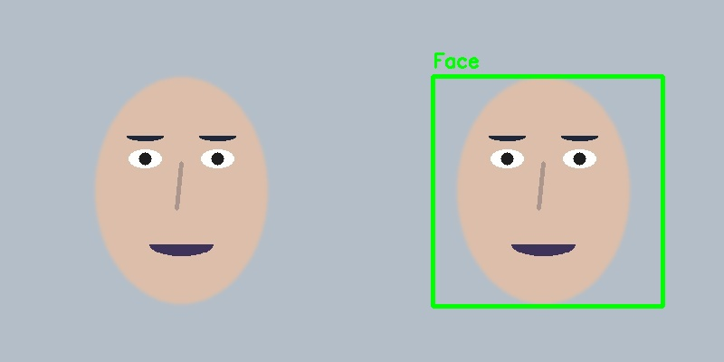
Left: input image. Right: detected face marked with a green bounding box using the Haar Cascade classifier.

Experiment 39: Vehicle Detection in a Video Frame using OpenCV
Aim:
To detect vehicles (cars) in a video frame/image using a pre-trained Haar Cascade classifier for cars.
Algorithm:
1. Import OpenCV.
2. Load a pre-trained car/vehicle Haar Cascade XML file (e.g. cars.xml).
3. Read the video using cv2.VideoCapture() (or a single frame/image).
4. Convert each frame to grayscale.
5. Call detectMultiScale() on the grayscale frame to get bounding boxes of detected vehicles.
6. Draw rectangles around each detected vehicle.
7. Display the annotated frame; repeat for each frame of the video.
Program (Python):
import cv2

car_cascade = cv2.CascadeClassifier("cars.xml")
cap = cv2.VideoCapture("traffic_video.mp4")

while True:
ret, frame = cap.read()
if not ret:
break

gray = cv2.cvtColor(frame, cv2.COLOR_BGR2GRAY)
cars = car_cascade.detectMultiScale(gray, scaleFactor=1.05, minNeighbors=3, minSize=(40, 40))

for (x, y, w, h) in cars:
cv2.rectangle(frame, (x, y), (x + w, y + h), (0, 0, 255), 3)
cv2.putText(frame, "Vehicle", (x, y - 8), cv2.FONT_HERSHEY_SIMPLEX, 0.6, (0, 0, 255), 2)

cv2.imshow("Vehicle Detection", frame)
if cv2.waitKey(30) & 0xFF == ord('q'):
break

cap.release()
cv2.destroyAllWindows()
Output:
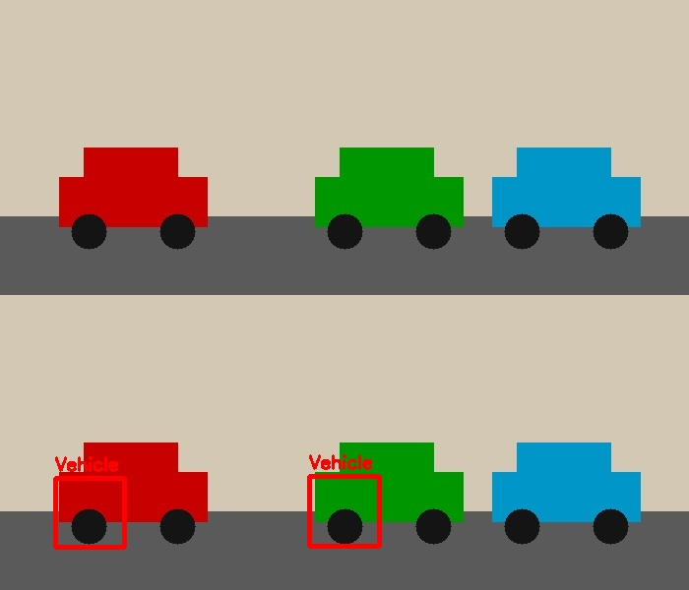
Top: original frame. Bottom: detected vehicles marked with red bounding boxes.

Experiment 40: Draw Rectangular Shape and Extract Objects
Aim:
To draw a rectangle around a region of interest (ROI) in an image and extract (crop out) that object from the image.
Algorithm:
1. Import OpenCV.
2. Read the input image.
3. Define the rectangle's top-left coordinates (x, y) and its width and height.
4. Draw the rectangle on a copy of the image using cv2.rectangle() to mark the region of interest.
5. Extract the same region from the original image using array slicing: roi = img[y:y+h, x:x+w].
6. Display and save both the marked image and the extracted object.
Program (Python):
import cv2

img = cv2.imread("image.jpg")

x, y, w, h = 90, 145, 150, 180 # region of interest

# Draw rectangle on a copy to mark the ROI
marked = img.copy()
cv2.rectangle(marked, (x, y), (x + w, y + h), (0, 0, 255), 3)

# Extract (crop) the object using slicing
extracted_object = img[y:y + h, x:x + w]

cv2.imwrite("extracted_object.jpg", extracted_object)
cv2.imshow("Marked Image", marked)
cv2.imshow("Extracted Object", extracted_object)
cv2.waitKey(0)
cv2.destroyAllWindows()
Output:
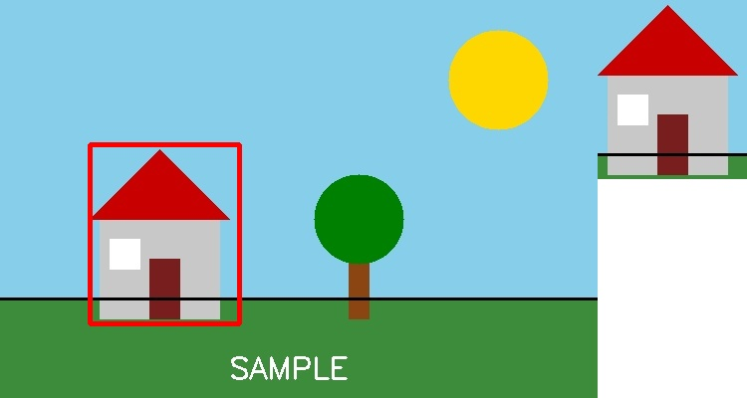
Left: image with rectangle marking the region of interest. Right: the extracted (cropped) object.

